Driver Installation

The installation of driving program

Notice:
- Please read manual carefully before using digital camera. Digital camera is high-tech product; improper operation may result in damage.
- Take out camera from package carefully so as not to damage its components.
- Fix camera position before connecting USB 2.0 cable.
- Don't disconnect USB 2.0 cable when capturing image.
- The USB device of this camera has the functions of hot swap and pnp; it's easy for installation and no need to restart computer.
- Connect camera with computer USB 2.0 interface using USB 2.0 cable.

Installation process under Windows2000
1．The system will report “found out new hardware” after accessing SW digital camera’s USB interface. Then install the driver by using hardware guide, and press “next”.

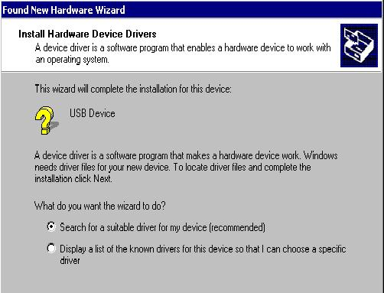
2．Choose the option of “search for a suitable driver for my device (recommendation)”, and then press” next”.

3．Choose “Specify a location” in the new window, then press” next”.
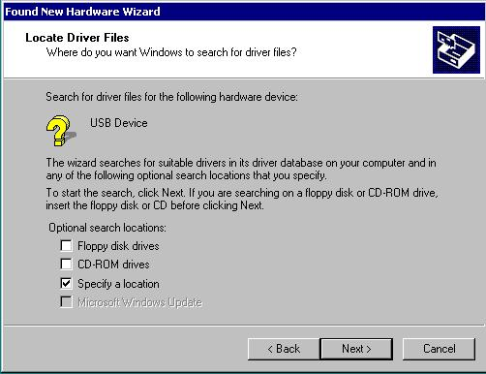

4．Click “browse” button, and choose the path of driver, then press “OK”.

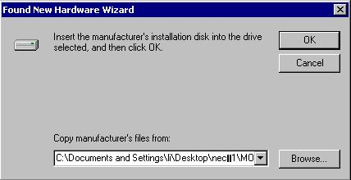

5．The setup wizard will find out related driver after searching, and press “next”.

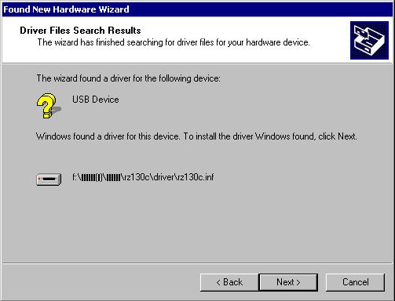

6．After copying the files, the setup wizard will finish installing, and then press “Finish”

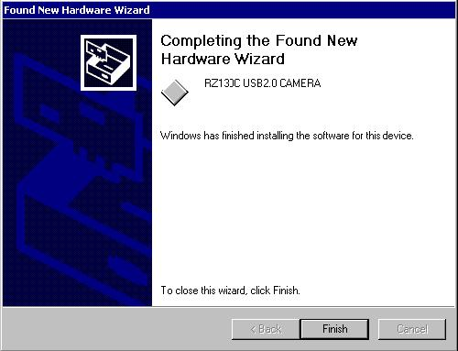
Until now, the driver’s manual installation is finished. The digital camera can be normally used at once.

Installation process under WindowsXP

- The system will report “found out new hardware” after accessing SW digital camera’s USB interface. Choose the option of “no”, and then press “next”

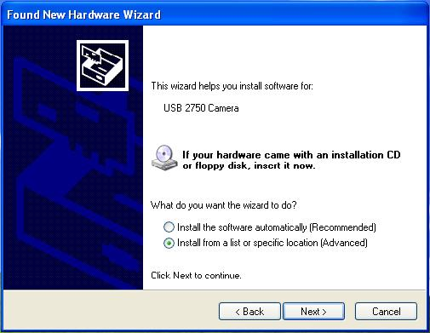
2．Choose “install from the list or assigned position”, then press “next”.

3．Choose “search the optimal driver on these positions”, and check the option of “Include this location in the search”, click “browse”, and choose the path of the driver. Then click “Next”.

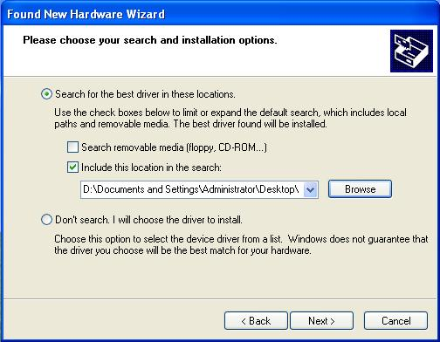

4．System will prompt the programme doesn’t pass the test of Windows MS standard, press “still continue”. (Since whether pass Windows MS standard test or not won’t effect camera’s use.)
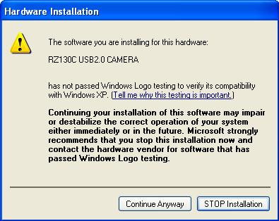

5．After copying the files, the setup wizard will finish installing, then press “Finish”.

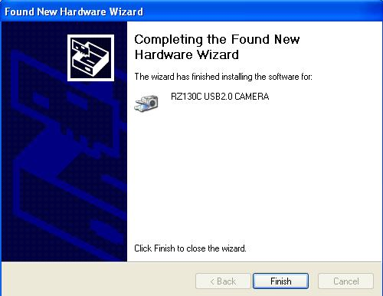

Thus, the driver’s manual installation is finished. The digital camera can be normally used right away.

